1. Chino Latino Enterprise

|  |  |  |
| --- | --- | --- |
| J.T. Kim | 630 461 6144 | jtkimnlu@gmail.com |
| Raul Rivera | 773 426 7427 | RaulMariana97@gmail.com |

3.

|  |  |
| --- | --- |
| Date and Time of Meeting | Wednesdays at 6pm on Google Docs |
| Method of Communication | Google Docs Chat Feature, Text, Email |

1. Team Rules and Exceptions
   1. Any conflicts will be resolved in a calm well-mannered way unless the conflict gets too big to where the teacher must be involved
   2. If a member misses one meeting they will be notified and have to pick up their part of the slack, if they miss more than two or three, the professor will be notified
   3. A team member that is not picking up their part of the slack will have to face the penalties of minus points on their final grade as voted on by the other peers
2. Code of Ethics
   1. One must be present at all times when the group is meeting in a well professional manner
   2. One must be on time and must alert other team members if anything happens and they cannot make it
   3. One must be truthful and honest when talking to team members about anything at all whether it is the group work itself or telling them why they missed a meeting

|  |  |
| --- | --- |
| Planning Phase | Week 2 |
| Requirements Analysis | Week 2 |
| Requirements Analysis pt 2 | Week 5 |
| Design | Week 6 |
| Development | Week 7 |
| Integration and Test | Week 8 |

1. Signatures

J.T. Kim x J.T. Kim

Raul Rivera x Raul Rivera

Part 2

1. Project Scope – What is a website/app chat feature
   1. A website app chat feature is usually a feature on a app or website that allows users to communicate with each other via text. A great example of this is in video games when players are allowed to message each other during the game. Another great example is when you are working on google docs with a friend or a group. You can use the chat feature to talk to one another while doing the project
2. Current market examples
   1. Facebook – though you can chat anytime the best way to use it would be to download messenger which allows you message instantly with your friends. A new user will be prompted to download messenger. 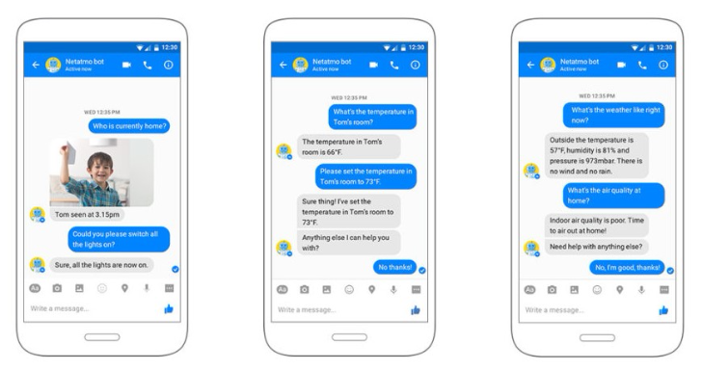
   2. Apex Legends – this is a video game that allows you to chat with your friends during the game. To chat one must press the enter button and type in their message and press enter again to send
   3. Twitter – This app allows users to message each other via DM. DM stands for direct message however to be able to receive and send to each other you must be following the user and they must be following you back. 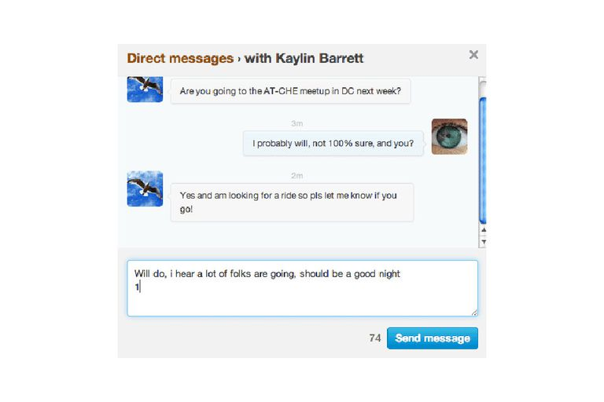
   4. Google Docs – in this app which allows users to work on a document together one can select the chat feature on the top of the screen and chat with other members in the group 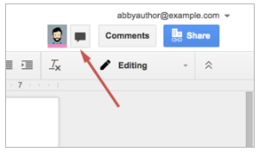 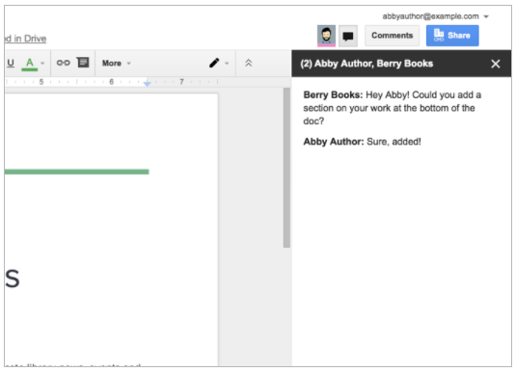
   5. Snapchat – snapchat is an app that allows you to post stories of yourself or watch other stories. You can also send each other images and videos called snaps. In this app you can also chat and message each other just by typing what you want to the username you want. The only requirement is that you must be friends beforehand. 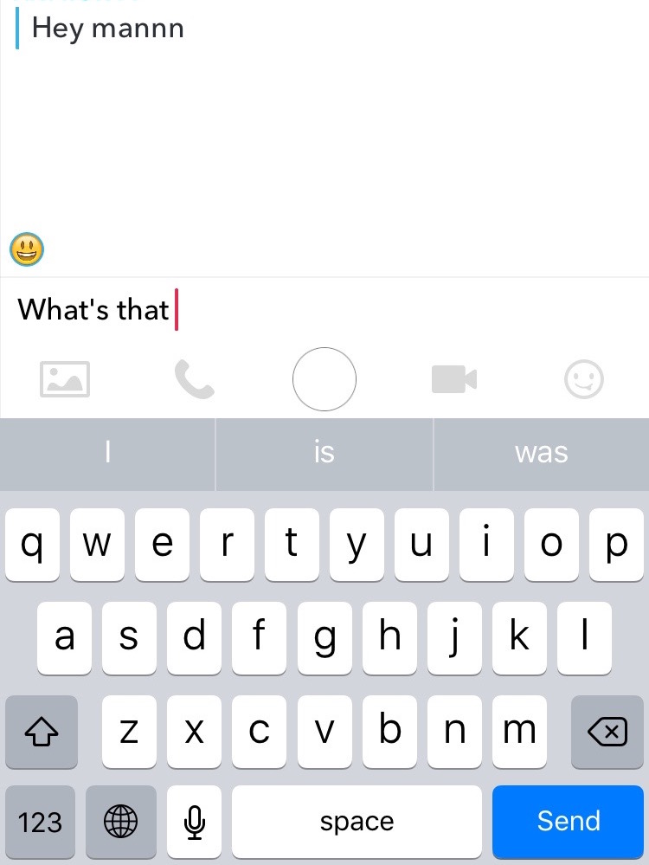
3. Requirement Analysis
   1. Instant Messaging
   2. Avatars, icons, images, etc
   3. Neat Interface
   4. Handle errors and gives feedback to users
   5. Send images
   6. Change Font
   7. Sound Effects